Clocks & Calendars Practice

# 20 Minutes – (Don’t skip any questions)

1. What is the angle included between the hands at $2:19 p.m.$?

|  |  |  |  |  |
| --- | --- | --- | --- | --- |
| $39.5$ | $42$ | $54$ | $44.5$ | $43$ |

1. The minute hand is half as long as the hour hand. What is the ratio of the distance travelled by the minute hand in 6 hours and the distance by the hour hand in 1 day?

|  |  |  |  |  |
| --- | --- | --- | --- | --- |
| $3:4$ | $6:24$ | $3:1$ | $6:1$ | $1:6$ |

1. What is the angle between the hour and the minute hands $15$ minutes after $10:31$?

|  |  |  |  |  |
| --- | --- | --- | --- | --- |
| $110$ | $129.5$ | $130$ | $50$ | $47$ |

1. What is the difference in the degree measures of the angles formed by the hour hand and the minute hand of a clock at $12:45$ and $5:45$?

|  |  |  |  |  |
| --- | --- | --- | --- | --- |
| $17.5$ | $13.5$ | $11$ | $20.5$ | $15$ |

1. If March 14, 2011 is a Monday, what day would it 16th October, 2012 be?

|  |  |  |  |  |
| --- | --- | --- | --- | --- |
| $Sunday$ | $Monday$ | $Tuesday$ | $Wednesday$ | $Thursday$ |

1. What day was it on 5th January 2009? (Calculate using today’s day and date)

|  |  |  |  |  |
| --- | --- | --- | --- | --- |
| $Sunday$ | $Monday$ | $Tuesday$ | $Wednesday$ | $Thursday$ |

1. What day would it be on 1th January 2037? (Calculate using today’s day and date)

|  |  |  |  |  |
| --- | --- | --- | --- | --- |
| $Sunday$ | $Monday$ | $Tuesday$ | $Wednesday$ | $Thursday$ |

1. What is the difference in the degree measures of the angles formed by the hour hand and the minute hand of a clock at $1:50$?

|  |  |  |  |  |
| --- | --- | --- | --- | --- |
| $90$ | $100$ | $105$ | $115$ | $120$ |

1. If the clock gains 1 second per minute, and if the time is exactly $1:23$ now, what would be the time showed by the clock after 45 minutes?

|  |  |  |  |  |
| --- | --- | --- | --- | --- |
| $2:07:45$ | $2:08:45$ | $2:09:50$ | $2:10:45$ | $2:11:45$ |

1. Quantitative Comparison:

|  |  |
| --- | --- |
| Quantity A | Quantity B |
| The measure in degrees of the smaller angle formed by the hour hand and the minute hand of a clock at 7:37 | The measure in degrees of the smaller angle formed by the hour hand and the minute hand of a clock at 4:23 |

|  |  |  |  |
| --- | --- | --- | --- |
| 1. A > B | 1. B > A | 1. A = B | 1. Can’t be determined |

1. Let $g\left(x\right)=8x+2$. If $g\left(y\right)=-62$. What is the value of $y$? (Numeric Entry)

|  |
| --- |
|  |

1. What is the input value other than $-7$ for which $h(x)=3$? (Numeric Entry)

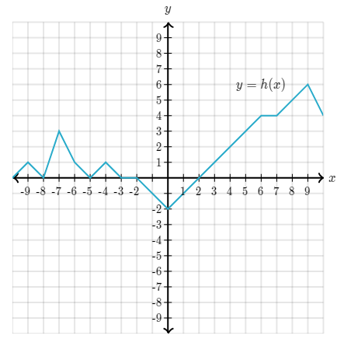

|  |  |
| --- | --- |
| $$x =$$ |  |

1. For a given input value $x$, the function $f$ outputs a value $y$ to satisfy the following equation.

$$y+6=5\left(x-4\right)$$

What is the formula for $f(z)$ in terms of $z$?

|  |  |  |  |  |
| --- | --- | --- | --- | --- |
| $z+6$ | $5z-26$ | $5(z-4)$ | $\frac{z+6}{5}+4$ | $\frac{z+10}{5}$ |

1. Valak is a taxi driver. $M(n)$ models Valak’s fee (in dollors) for her $n^{th}$ drive on a certain day. What does the statement $M(8)<M(4)$ mean? (Select all that apply)

|  |
| --- |
| 1. Valak earned $\$8$ for a drive that was earlier than a drive for which he earned . |
| 1. Valak earned $\$8$ for fewer drives than the number of drives for which he earned . |
| 1. Valak earned less money for her $8^{th}$ than she earned for her $4^{th}$ drive. |

1. Annabelle’s class had a math exam where the grades were between 0 and 10. $N(g)$ models the number of students whose grade on the exam was $g$. What does the statement $N(8)>2N(5)$ mean? (Select all that apply)

|  |
| --- |
| 1. The number of students whose grade was higher than 5 is greater than the number of students whose grade was 5 or lower. |
| 1. The number of students whose grade was 8 more than twice the number of students whose grade was 5. |
| 1. There are 8 students whose grade was higher than twice the grade of another group of 5 students. |

1. What is the domain of h?

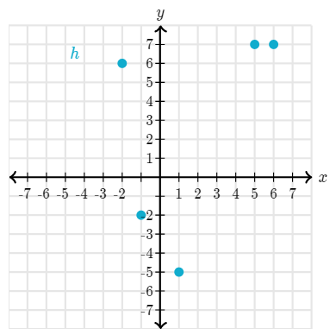

|  |  |  |  |  |
| --- | --- | --- | --- | --- |
| $-5≤x≤7$ | $\{-5,-2,6,7\}$ | $-2≤x≤6$ | $\{-2,-1,1,5,6\}$ | $None$ |